**Computer Networks Lab 4**

**Name: Vaibhav Chaudhari**

**ID: 2017B5A70834G**

**- The text message typed from the client terminal to be sent to the server**

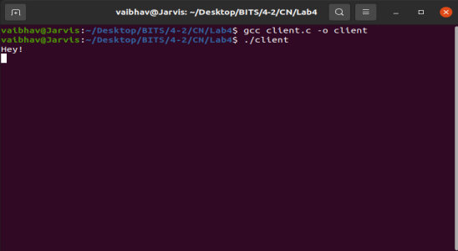

**- The display of client's sent messages on the server's terminal**

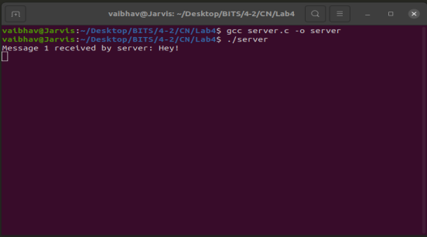

**- The same two screenshots above must be repeated for the opposite direction message example, i.e, server to client message transfer and termination**

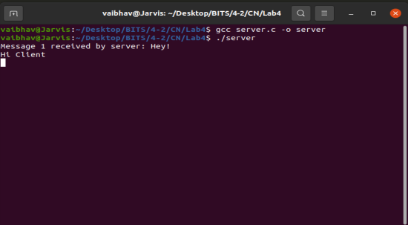 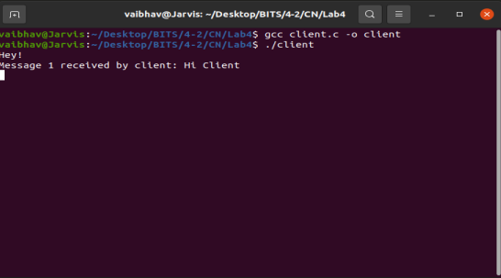

**- Terminate the client program by typing 'exit' at the client terminal**

**- Terminate the server by typing 'exit' at the server terminal**